STATISTICS 101; Solution Set 1

(1)
Distributions
Hurricanes
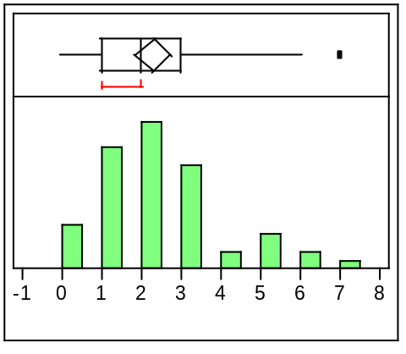

Quantiles
100.0% | maximum | 7.0000
99.5% |  | 7.0000
97.5% |  | 6.5500
90.0% |  | 5.0000
75.0% | quartile | 3.0000
50.0% | median | 2.0000
25.0% | quartile | 1.0000
10.0% |  | 0.8000
2.5% |  | 0.0000
0.5% |  | 0.0000
0.0% | minimum | 0.0000
Moments
Mean | 2.2982456
Std Dev | 1.5919991
Std Err Mean | 0.2108654
upper 95% Mean | 2.7206598
lower 95% Mean | 1.8758314
N | 57

The graph of all the hurricane data shows a distribution that is skewed to the right with a mean of 2.3 hurricanes and a standard deviation (spread) of 1.59.

Distributions
Hurricanes 1944-1969
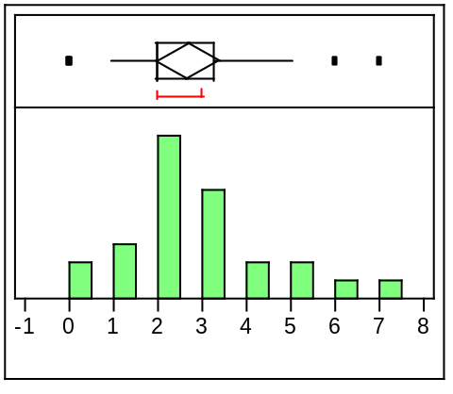

Quantiles
100.0% | maximum | 7.0000
99.5% |  | 7.0000
97.5% |  | 7.0000
90.0% |  | 5.3000
75.0% | quartile | 3.2500
50.0% | median | 2.0000
25.0% | quartile | 2.0000
10.0% |  | 0.7000
2.5% |  | 0.0000
0.5% |  | 0.0000
0.0% | minimum | 0.0000
Moments
Mean | 2.6923077
Std Dev | 1.6916082
Std Err Mean | 0.3317517
upper 95% Mean | 3.375563
lower 95% Mean | 2.0090523
N | 26

The graph of the hurricane data from 1944-1969 shows a distribution that is slightly skewed to the right with a mean of 2.7 hurricanes and a standard deviation (spread) of 1.69.

Distributions
Hurricanes 1970-2000
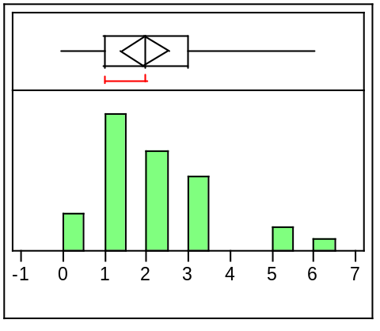

Quantiles
100.0% | maximum | 6.0000
99.5% |  | 6.0000
97.5% |  | 6.0000
90.0% |  | 4.6000
75.0% | quartile | 3.0000
50.0% | median | 2.0000
25.0% | quartile | 1.0000
10.0% |  | 0.2000
2.5% |  | 0.0000
0.5% |  | 0.0000
0.0% | minimum | 0.0000
Moments
Mean | 1.9677419
Std Dev | 1.4487666
Std Err Mean | 0.2602062
upper 95% Mean | 2.4991538
lower 95% Mean | 1.43633
N | 31

The graph of the hurricane data from 1970-2000 shows a distribution that is skewed to the right with a mean of 2 hurricanes and a standard deviation (spread) of 1.44.

Both the 1944-1969 and 1970-2000 data sets have histograms that are skewed to the right. However the mean number of hurricanes is somewhat smaller (2 vs. 2.7) for the 1970-200 data. Given the spread of the data, we can say that overall, the two distributions look fairly similar.

(2) Problem 1.92

A.
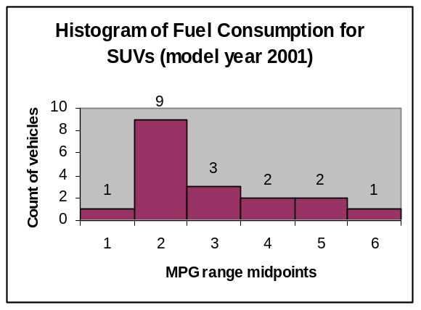
This histogram shows a distribution skewed to the right with a center at 18 MPG and a spread of 10 MPG.

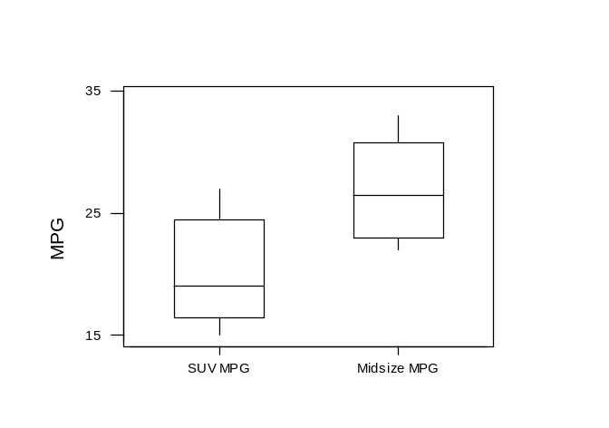
B. The box plots show that the MPG for Midsize cars is much greater than for SUVs. It also appears that the distribution of MPG for Midsize cars is more symmetrical than for SUVs.

(3) Problem 1.93
A.

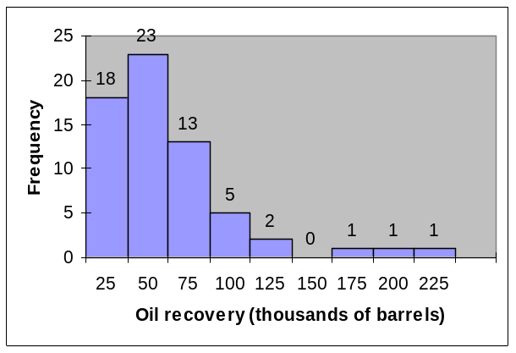

The distribution is heavily skewed to the right.

B. The mean is 48.25 and the median is 37.9. Because the distribution is skewed to the right the mean is greater than the median.

C. The five-number summary is 204.9, 59.45, 37.9, 21.6, and 2. Note the large range between the third quartile and the maximum value. This reflects the skewed nature of the data. (Note: quartiles were calculated using the Excel percentile command. The values may differ slightly than finding the quartiles by hand.)

(4) Problem 1.94
The IQR is 37.85. The value 204.9 lies more than 1.5×IQR above the third quartile and is considered an outlier. There are five other values that would be considered high outliers using this criteria.

(5) A.

Distributions
log(recovery)
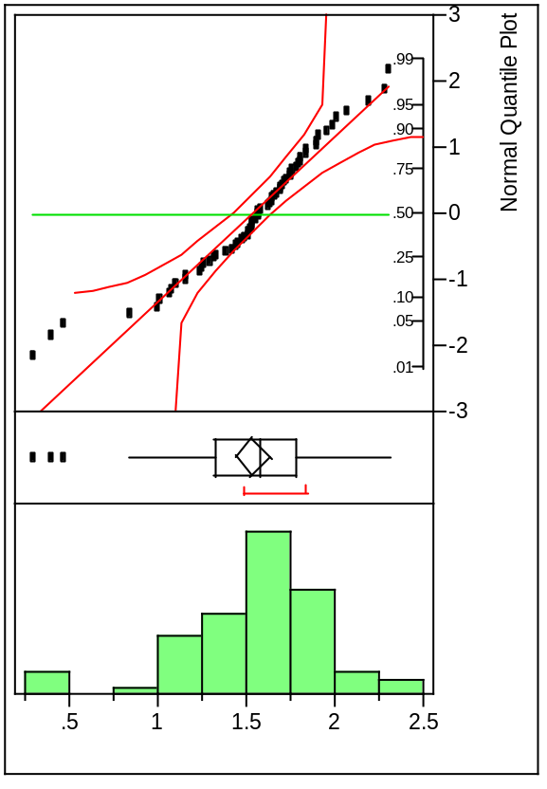

Quantiles
100.0% | maximum | 2.3115
99.5% |  | 2.3115
97.5% |  | 2.2995
90.0% |  | 1.9773
75.0% | quartile | 1.7835
50.0% | median | 1.5775
25.0% | quartile | 1.3304
10.0% |  | 1.0460
2.5% |  | 0.3616
0.5% |  | 0.3010
0.0% | minimum | 0.3010
Moments
Mean | 1.5374473
Std Dev | 0.3995651
Std Err Mean | 0.0499456
upper 95% Mean | 1.6372557
lower 95% Mean | 1.4376389
N | 64

The distribution is roughly symmetric.

B. Normal Quantile Plots

The quantile plot for the log data is given in part A.
Below is the normal quantile plot for the original data:

Distributions
Recovery
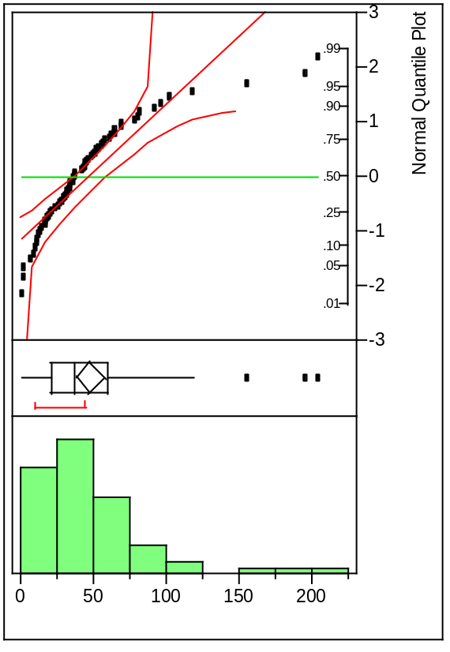

The normal quantile plot of the original data is clearly not normal; in fact, by looking at this plot we can see that the data is skewed to the right. In contrast, the normal quantile plot is far straighter with a few low outliers.

Extra Credit
(A) Mean: 5
Median: 3.3 (Take average of 3.1 and 3.5 since we have an even number of values)
Trimmed Mean: 3.4
(B) Sensitivity Curves (see next page)
(C) The sensitivity curves give us a way to measure the magnitude of the affect of aberrant data on measures. Looking at the sensitivity curve for mean, we see that aberrant data has a tremendous affect on mean. A large value of X can make the mean any number on the real line. On the other hand, the sensitivity curves for median and trimmed mean have less of a range. This means that large values (either positive or negative) don’t affect either of these measures much. In other words, the median and the trimmed mean are more resistant (median more than trimmed mean) to outliers than the mean is.


